**Ticket booking on Cleartrip**

**Cleartrip** is a platform that allows you to book flight online. Whether you’re planning a domestic trip or an international journey, Cleartrip offers great deals on air travel. You can find the cheapest flights and make your bookings conveniently. Additionally, Cleartrip also provides hotel booking services, making it a one-stop solution for travelers.

1. Open [**http://www.Cleartrip.com**](http://www.Cleartrip.com) website.
2. A pop-up window opens, enter your mobile number.

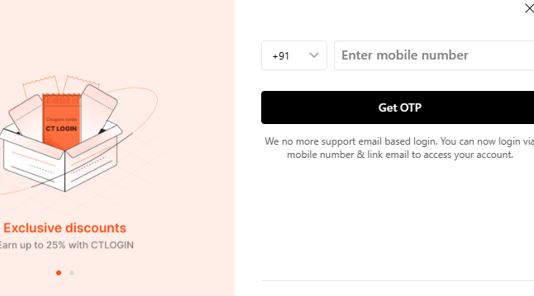

1. Enter OTP number sent to your registered mobile number.

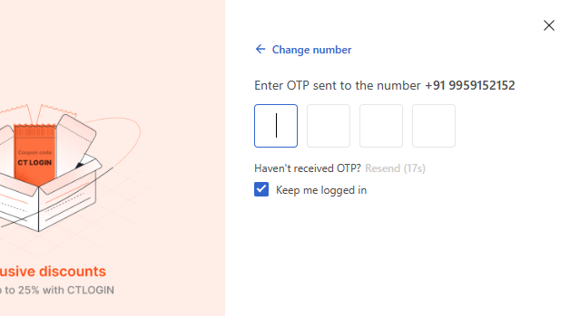

1. Enter your email id, click **Next** or **Skip** (if you don’t want to receive notifications).
2. It navigates to main page, on left pane, select mode of transport that is **flight** or **bus**.

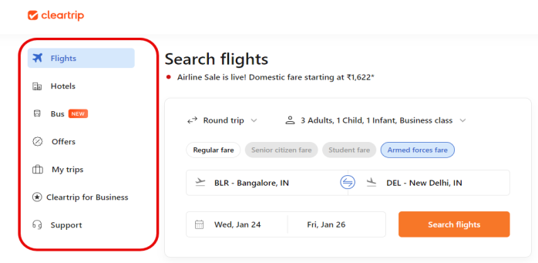

6. Select **Flights** if you want to travel by flight.

7. Select **One way** or **Round trip** (traveling from a starting point to a destination and then returning back to starting point).

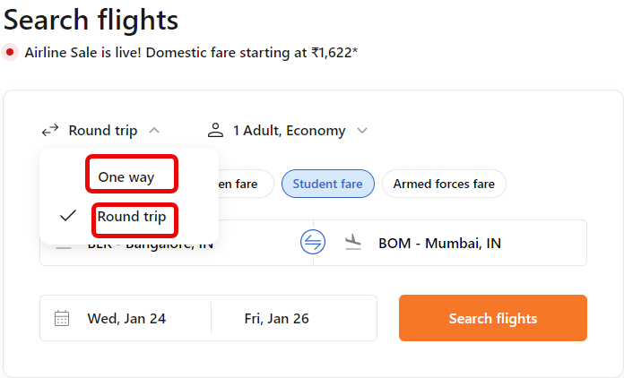

8. Select **Economy/Business class/First class/Premium economy**, accordingly ticket prices vary.

9. Select **Regular fare**, if you are traveling with **Adults, Children, Infants**.

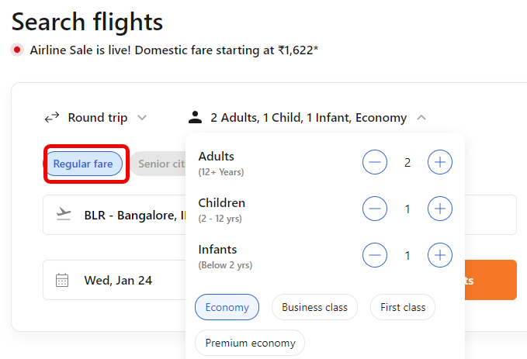

10. Select **Senior citizen fare**, if your age is above 60 years. You can add only adults.

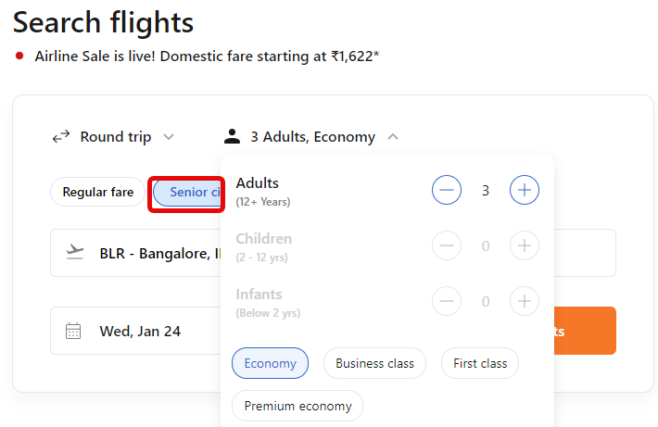

11. Select **Student fare** if you are above 12 years with valid id. You can add only adults.

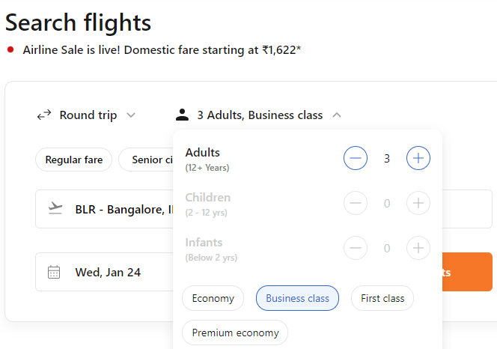

12. Select **Armed forces fare** if you are serving/retired armed forces personnel and also dependents can avail this offer. You can add adults, children and infants.

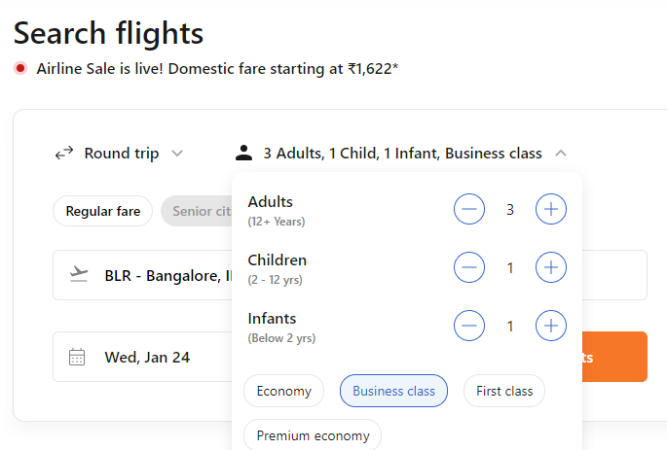

13. Select **Where from**, drop down list appears to select jumping-off point in your city.

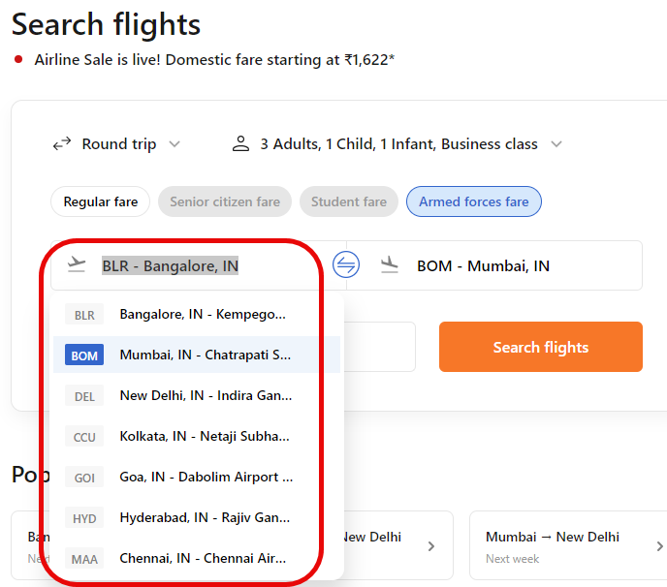

14. Select **Where to**, a drop down list appears to select the destination place.

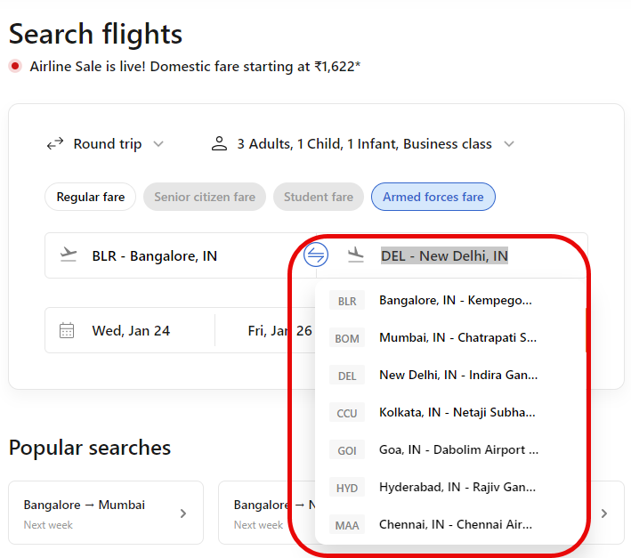

15. Select the **date** you want to travel.

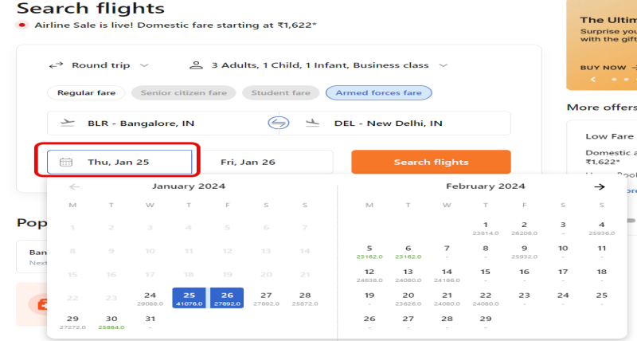

16. If it is a round trip, Select the **date** when you want to travel back.

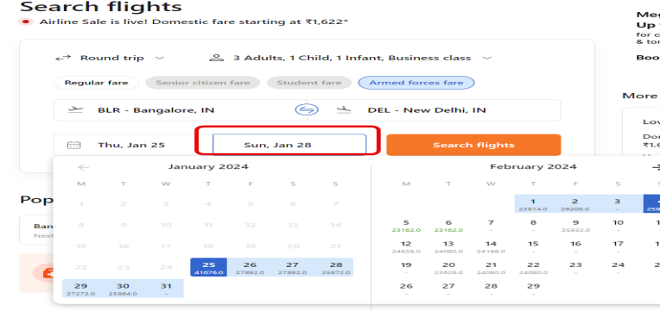

17. Now, click **Search flights**.

18. The next page shows the list of flights available.

* On the top, details of your journey are displayed.
* On the left pane, select stops, departure time from jumping-off point, and departure time from destination.
* Also select one way price, airlines, trip duration, and layover duration.
* On the right pane, click **Book now**.

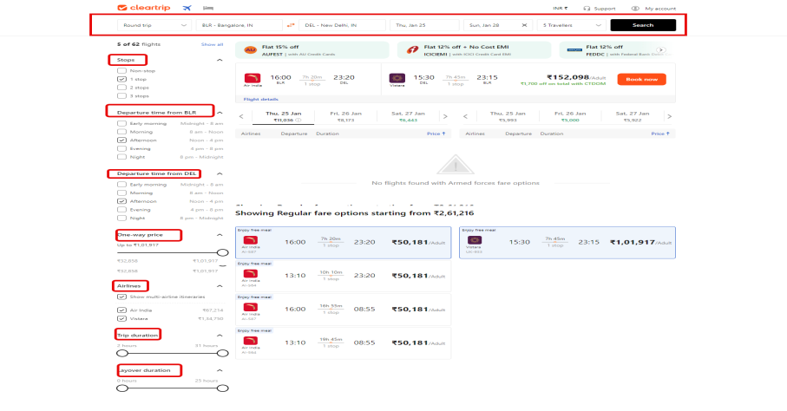

19. The next page displays review itinerary.

* Check cancellation policy and date change policy, in case you want to cancel the ticket or change the dates respectively.
* Check total price on right pane.
* Click **Continue**.

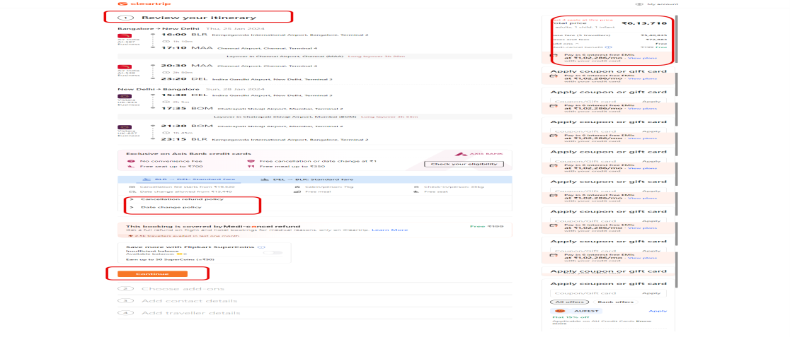

20. In the next page, add your mobile number and email id. Click **Continue**.

21. Select the mode of payment. Click **Continue**.

22. Online booking details are sent to your registered mobile number and email id. Click **Logout**.